34.102: a) 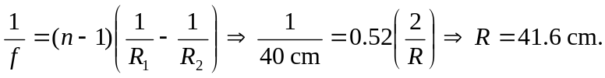
At the air–lens interface: 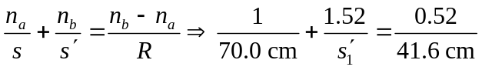
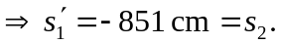
At the lens–water interface: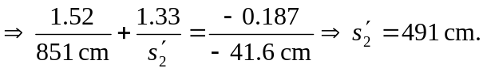
The mirror reflects the image back (since there is just 90 cm between the lens and mirror.) So, the position of the image is 401 cm to the left of the mirror, or 311 cm to the left of the lens. So:
At the water–lens interface: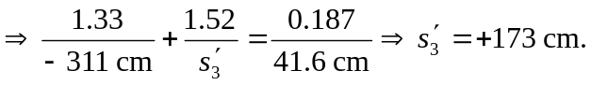
At the lens–air interface: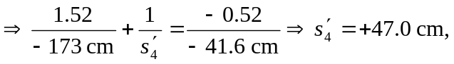 to the left of lens.
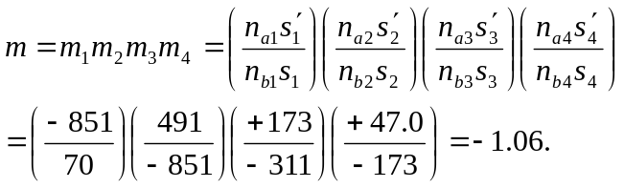
(Note all the indices of refraction cancel out.)
b) The image is real.
c) The image is inverted.
d) The final height is

